Wiring connections.

568A Ribbon Breakout Box

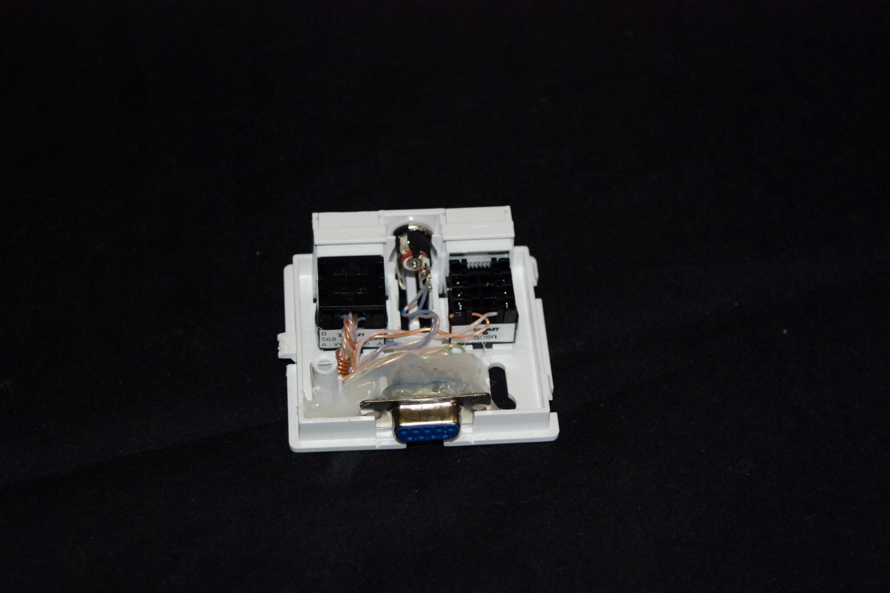Bl/Wh Red+ Brown Tip +

Wh/Bl Yellow+ Orange Sleeve -

Or/Wh Gray Start Common

Wh/Or Green Normally Open

Gr/Wh P3 1 DB9 pin 2

Wh/Gr P3 2 DB9 pin 5

Br/Wh

Wh/Br P3 3 DB9 pin 3

